A SYNOPSIS ON

Text Editor

Submitted in partial fulfilment of the requirement for the award of the degree
of BACHELOR OF COMPUTER APPLICATION

Submitted by: Mayank Bisht

Sec. - A ( G2 )
BCA ( III )
Roll No.: 68

Project Number : M11

Under the Guidance of Dr. Jitendra Chaudhary, Associate Professor,
School of Computing



Graphic Era Hill University, Bhimtal, Uttarakhand March-2025


CANDIDATE’S DECLARATION
I/We hereby certify that the work which is being presented in the Synopsis entitled “Text Editor” in partial fulfilment of the requirements for the award of the Degree of Bachelor Computer Application of the Graphic Era Hill University, Bhimtal shall be carried out by the undersigned under the supervision of Dr. Jitendra Chaudhary, Associate Professor, School of Computing, Graphic Era Hill University, Bhimtal.

Mayank Bisht 2471122 signature

The above-mentioned students shall be working under the supervision of the undersigned on the
“Text Editor”.

Signature Signature
Supervisor Head of the Department

Internal Evaluation (By DPRC Committee)

Status of the Synopsis: Accepted / Rejected
Any Comments:

Name of the Committee Members: Signature with Date

1.
2.
Table of Contents

Chapter No. | Description | Page No.
Chapter 1 | • Introduction and Problem Statement | 4
Chapter 2 | • Background / Literature Survey | 5
Chapter 3 | • Objectives | 6
Chapter 4 | • Hardware and Software Requirements | 7
Chapter 5 | • Possible Approach / Algorithms | 8-9
Chapter 6 | • Data Structures Used | 10
 | • Flow chart | 11
 | • References & Conclusion | 12
 | • Acknowledgment | 13

Chapter 1: Introduction and Problem Statement

The advancement of web technologies has made it possible to develop powerful applications directly within the browser. One such application is a Text Editor Website, which provides an efficient way to create, edit, and format text without depending on bulky desktop applications. This project focuses on building a simple yet practical text editor using React.js, ensuring accessibility, speed, and ease of use.

The introduction of the project lies in addressing the needs of modern users who require quick editing tools without installing heavy software. Tools like Notepad are too limited, while advanced platforms like Google Docs or MS Word are overloaded with features that are unnecessary for basic use. Users often face challenges when they just want an editor with essential formatting functions in a lightweight environment.

The problem statement therefore centers on the lack of an efficient, browser-based solution that combines simplicity with usability. While existing solutions either compromise on features or overload the user, this project seeks to provide a middle-ground alternative. By leveraging React’s component-based architecture, the project ensures flexibility, modularity, and scalability, making it adaptable for future improvements.

Thus, the purpose of the project is to provide a user-friendly text editing platform that is accessible anytime, anywhere, and meets the basic requirements of students, professionals, and casual users alike. This sets the foundation for further exploration into web-based productivity tools.

Chapter 2: Background/ Literature Survey

Several existing text editors were studied to understand their design and features. Applications like Notepad and WordPad are widely used for basic editing, but they lack advanced formatting. On the other hand, platforms such as Google Docs and Microsoft Word provide robust features but require high system resources and can overwhelm users. The literature shows that there is a gap for an editor that is both lightweight and functional.
Research into web technologies revealed that React.js is one of the most suitable frameworks for this project. It provides reusability of components, efficient state management, and high performance, which are crucial for building real-time editing applications. Articles from MDN and W3Schools highlight React’s virtual DOM and component-based architecture as key features for interactive web development.
From a user perspective, the trend has shifted toward online tools that do not require installations and can be accessed across devices. This is evident from the growing popularity of cloud-based applications. However, many of these require continuous internet access and sometimes user accounts, which limit accessibility.
The literature survey concludes that there is scope for creating an open, lightweight, and accessible text editor that can bridge the gap between simplicity and complexity. This motivates the development of a React-based editor that fulfills these needs while remaining scalable.

Chapter 3: Objectives
The main objective of the Text Editor Website project is to create a browser-based tool that is easy to use, accessible, and responsive. The project aims to deliver an editor that balances the simplicity of Notepad with the flexibility of advanced editors.

Some of the specific objectives include:
- Providing formatting options such as bold, italic, underline, font size, and text coloring.
- Implementing dark and light themes to enhance user experience.
- Ensuring cross-device compatibility, so that the editor works on desktops, laptops, and mobile browsers.
- Keeping the application lightweight by using React’s component reusability and efficient state handling.

Another important objective is to design the system in a way that it remains scalable. This means new features such as exporting text as PDF/Word, collaborative editing, and AI-assisted suggestions can be added without rebuilding the entire application.

Overall, the project seeks to create an editor that is not only useful in its current state but also adaptable for future use cases, making it a versatile tool for a variety of users.

Chapter 4: Hardware and Software Requirements

Hardware Requirements:
- Minimum 4 GB RAM
- Dual-core processor (Intel/AMD/Apple M1 or higher)
- 500 MB free storage
- Internet connectivity for deployment and testing

Software Requirements:
- Operating System: Windows / macOS / Linux
- Node.js and npm installed
- React.js library and supporting packages
- Code Editor: VS Code (or equivalent)
- Web Browser: Google Chrome / Safari / Edge

Chapter 5: Possible Approach/ Algorithms

The project follows a modular approach where the text editor is built as a React application using reusable components. The editor uses state management in React to handle real-time text changes.

Algorithm (Simplified Steps):
- Initialize a React project and set up editor components.
- Capture user input using controlled text fields.
- Apply formatting functions (bold, italic, underline, font size, color) using state and event handling.
- Store user preferences (like theme selection) in local storage for persistence.
- Render updated text dynamically on the screen.
- (Optional) Implement undo/redo feature using a stack-based approach.

This approach ensures smooth interaction, minimal lag, and efficient use of browser resources.

Algorithm:
- Start / Initialize
  - Read saved state from localStorage (content, theme).
  - Initialize React state: content, selection, formatState, theme, undoStack, redoStack.
  - Render UI: Toolbar (Bold/Italic/Underline/Size/Color), Theme switch, Editor area, Counters, Export buttons.
- User Input Loop
  - On every keystroke or paste, update content.
  - Push previous state to undoStack (debounced to avoid spam).
  - Clear redoStack.
- Formatting
  - When user clicks a format button or presses a shortcut (e.g., Ctrl+B), read current selection.
  - Apply format to selected text (rich text via contentEditable + Range API, or plain text rules).
  - Update content and formatState, then record history.
- Autosave & Persistence
  - Debounce autosave (e.g., 500 ms after last change) → store content + theme in localStorage.
- Undo/Redo
  - Undo pops from undoStack → pushes current state onto redoStack → sets content.
  - Redo pops from redoStack → pushes current state onto undoStack → sets content.
- Utilities
- Theme toggle: flip theme, persist to localStorage, re-render.
- Stats: compute word/char count on content change.
- Export: create a Blob from content (TXT/HTML) and trigger download.
- End
- On unmount/close, ensure latest autosave flushed.

Chapter 6: Data Structures Used

The project makes use of basic but effective data structures to manage text editing features. Arrays and objects are the most frequently used structures, while a stack is optionally implemented for undo/redo operations.
- Arrays are used to keep track of formatting actions. For example, each action can be stored in an array to help reconstruct text history.
- Objects are used for maintaining the current state of the editor, including font size, style, and theme preferences.
- Stack is used in undo/redo functionality. Since stack follows a Last In, First Out (LIFO) principle, it is suitable for reverting the most recent changes.

These data structures ensure that the editor handles user input smoothly and maintains performance while managing multiple changes.

Flow Chart
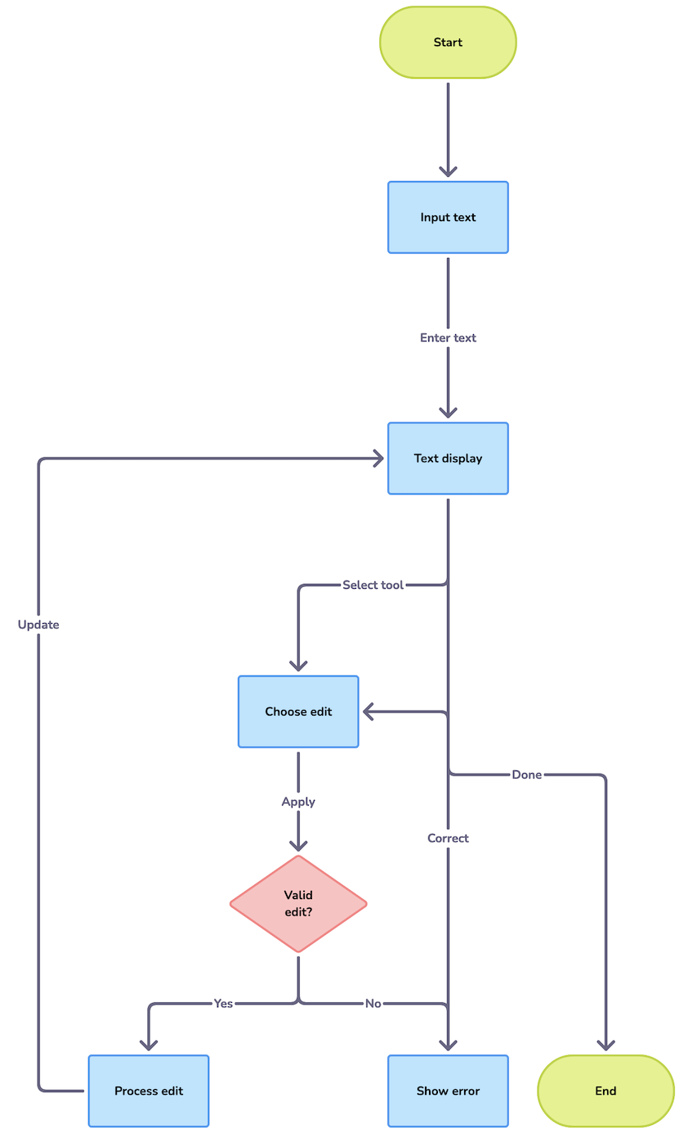
References:

- React.js Official Documentation – https://react.dev
- Mozilla Developer Network (MDN) – https://developer.mozilla.org
- TutorialsPoint, W3Schools – React and JavaScript tutorials
- Comparative study of Notepad, Google Docs, and MS Word
The Text Editor Website demonstrates how a modern framework like React can be used to create practical and user-friendly applications. The project balances simplicity with necessary functionality, providing essential features such as formatting tools and theme customization. It runs efficiently across devices and is scalable for future improvements. The project thus proves that web-based tools can successfully replace traditional software for basic editing tasks.

Conclusion

The Text Editor Website demonstrates how a modern framework like React can be used to create practical and user-friendly applications. The project balances simplicity with necessary functionality, providing essential features such as formatting tools and theme customization. It runs efficiently across devices and is scalable for future improvements. The project thus proves that web-based tools can successfully replace traditional software for basic editing tasks.

Acknowledgment & Thank You

We sincerely express our gratitude to Dr. Jitendra Chaudhary, Associate Professor, School of Computing, Graphic Era Hill University, Bhimtal, for his invaluable guidance and support throughout this project.
We also thank Graphic Era Hill University for providing us with the resources and platform to work on this project.
Lastly, we would like to extend our heartfelt appreciation to our friends, family, and peers for their constant encouragement and motivation.

Thank You!

